Software Requirements Specification Template
CSI 518—Software Engineering
22 February 2017

The following annotated template shall be used to complete the Software Requirements Specification (SRS) assignment of CSI 518. The instructor must approve any modifications to the overall structure of this document.

Template Usage:
Text contained within angle brackets (‘<’, ‘>’) shall be replaced by your project-specific information and/or details. For example, <Project Name> will be replaced with either ‘Smart Home’ or ‘Sensor Network’.

Italicized text is included to briefly annotate the purpose of each section within this template. This text should not appear in the final version of your submitted SRS document.

This cover page is not a part of the final template and should be removed before your SRS is submitted.

Acknowledgements:
Sections of this document are based upon the IEEE Guide to Software Requirements Specification (ANSI/IEEE Std. 830-1984). The SRS templates have also been used as guides in developing this template for the WSU-TC Spring 2005 CptS 322 course.

Permissions Grid

Software Requirements Specification

Version 1.1

Date : 3/12/17

Areeb Shakeel Khan
Lead Software Engineer

Prepared for
CSI 518 Software Engineering Course
Instructor: Dr. Mei Hwa Chen
Spring 2017

Revision History

Date | Description | Author | Comments
3/12/17 | Version 1.0 | Areeb Shakeel Khan

Document Approval

The following Software Requirements Specification has been accepted and approved by the following:
Signature | Printed Name | Title | Date
 | Areeb Shakeel Khan | Lead Software Eng. | 3/12/17
 | Dr. Mei Hwa Chen | Instructor, CSI 518

Table of Contents

Revision History ii
Document Approval ii
1. Introduction 1
1.1 Purpose 1
1.2 Scope 1
1.3 Definitions, Acronyms, and Abbreviations 2
1.4 References 2
1.5 Overview 2
2. General Description 2
2.1 Product Perspective 2
2.2 Product Functions 2
2.3 User Characteristics 3
2.4 General Constraints 3
2.5 Assumptions and Dependencies 3
3. Specific Requirements 2
3.1 External Interface Requirements 3
3.1.1 User Interfaces 3
3.1.2 Hardware Interfaces 3
3.1.3 Software Interfaces 3
3.1.4 Communications Interfaces 3
3.2 Functional Requirements 3
3.2.1 <Functional Requirement or Feature #1> 3
3.2.2 <Functional Requirement or Feature #2> 3
3.3 Data Requirements 3
3.4 Use Cases 3
3.4.1 Use Case #1 3
3.4.2 Use Case #2 3
3.5 Classes / Objects 3
3.5.1 <Class / Object #1> 3
3.5.2 <Class / Object #2> 3
3.6 Non-Functional Requirements 4
3.6.1 Performance 4
3.6.2 Reliability 4
3.6.3 Availability 4
3.6.4 Security 4
3.6.5 Maintainability 4
3.6.6 Portability 4
3.7 Inverse Requirements 4
3.8 Design Constraints 4
3.9 Logical Database Requirements 4
3.10 Other Requirements 4
4. Analysis Models 4
4.1 Sequence Diagrams 5
4.3 Data Flow Diagrams (DFD) 5
4.2 State-Transition Diagrams (STD) 5
5. Change Management Process 5
A. Appendices 5
A.1 Appendix 1 5
A.2 Appendix 2 5

Introduction

This Software Requirements Specification (SRS) aims to describe the Purpose, General description, Specific requirement, Functionality, Design model of the Permissions Grid version 1.0. In order to provide fully information, this document contains all the information needed by software Engineer to adequately design and implement the software product described by the requirements listed in the following part of this document.

Purpose
The purpose of this SRS is to describe and define the functions and requirements of Permissions Grid version 1.0. It has detailed information regarding the software so that anyone can understand the functionalities of the software.

Scope
Permission Grid version 1.0 has some but not all functionalities of an employee management system. It mainly concentrates on implementing the hierarchy of an organization which wants to carry out document sharing, payroll management and leave management in all of which hierarchy plays an important role.
Employees can upload documents, apply for leave and get pay-slips from this system, apart from that it keeps the track of all the employees, their managers their bonuses and their departments.

Definitions, Acronyms and Abbreviations
Acronym/Term | Definition
FR | Functional Requirement
ATE | Another Team Employee
Super Manager | Manager of the immediate manager.
ID | Identification Number

References
NA

Overview
This SRS is divided into 5 subsections:
The first part introduces Purpose, Scope, Definition, Acronyms, Abbreviations, References and Overview of the document.
The second part introduces product perspective, functions, user characteristics, general constraints, and dependencies.
The third part brings specific requirements, such as, external interface requirements, functional requirements, non-functional requirements, design requirements, database requirements.
The forth part will show various diagrams, for example Sequence Diagram, Data Flow Diagrams and State-Transition Diagrams.
The final part is the Change Management Process. It is used to identify and describe the process that will be used to update the SRS, as needed, when project scope or requirements change. Who can submit changes and by what means, and how will these changes be approved.

General Description

Permissions grid is an employee management system which has three types of users: admin, employee and manager. It mainly concentrates on implementing the hierarchy of an organization which wants to carry out document sharing, payroll management and leave management in all of which hierarchy plays an important role.

Product Perspective
Permissions Grid is a web application which has selective features of a traditional employee management system. It implements basic features of an employee management system and also enable employees and the managers to share files via directories, its main features:
Management of payroll
Employee record management.
Leave management system
Hierarchy based document sharing system.
Bonus allocation

Product Functions
- Register: The registration is necessary to get the login credentials.
- Login: Login credentials enable the employee to access the system.
- Update Profile: After registration, an employee can edit profile details.
- View Directories: Employee can view directories he has access to.
- Apply for Leave: Employee can apply for leave.
- Upload and Download files: Files can be uploaded to and downloaded from a directory by an employee.

- Create directories: A manager can create directories and assign access to his sub employees.
- ATE: A manager should be able to allot access an ATE.
- Manager can approve or deny a leave request from a sub employee.
- Manager can assign bonus to his sub employees.

- Maintain Payroll: Admin can assign pay and edit it.
- Generate pay slips: Admin generates pay-slips.

User Characteristics
Three types of users will be involved with this system

- Admin: Oversees the registration of new employees and maintains the organization profile of the employees. Apart from that admin assigns the managers and oversees the payroll.

- Employee: Carries out the registration process and maintains the profile. Employee is supposed to upload the documents to the directories.

- Manager: A manager is also an employee but with special privileges. If an employee is assigned to be the supervisor of another manager, he becomes a manager.
Manager covers the most functionalities in this system and hence is the most important.

General Constraints

Database capacity can hold only a certain number of employee details and files.

Assumptions and Dependencies
Server: Apache Tomcat 7.0
My SQL 6.4
Will be used in order to accomplish the project, machines that run it should run these too.

Specific Requirements

External Interface Requirements

User Interfaces
The home page has the login fields which enable an employee to login. Upon logging in the employees reach their respective profile.

Employee can edit the details, change password, view directories, apply for leave, view directories, upload documents to the directories via profile.

Employee search can be done with employee number, if no such employee is present the manager will be notified.

Employee search can also be done by name as the keyword, if no names match the search a message will be displayed stating “0 results found”.

Manager can assign bonus, ranging from 0 to 20 percent of the salary. If it is beyond the range, then an error message will be displayed.

While adding ATE the manager must insert the correct employee number of another team manager, if the employee number is not present, an error message will be shown.

Logout button will be present on every screen after the user is logged in.

Hardware Interfaces
NA

Software Interfaces
Browser: Chrome, Mozilla etc. (Client Side)
Database: MySQL 6.3 (Server Side)
Server: Apache Tomcat (Server Side)

Communications Interfaces
This product will be using HTTP, SMTP, FTP protocols.

Functional Requirements
Employee
FR 1:
TITLE: Registration
DESC: Employee should be able to register through the web application. The user must provide name, password and e-mail address. The username will be provided by the admin to the employee.
FR 2:
TITLE: Login
DESC: User can use the credentials set during registration to log in. If the user is unable to login, then system cannot let the user access any profile. If user has forgotten password, it can be retrieved by clicking on forgot password link.

FR 3:
TITLE: Password Retrieval
DESC: System will ask for email ID and check in the database if it is present, if so an email with new password will be sent to the email id, otherwise user will be redirected to the same page.
FR 4:
TITLE: Search
DESC: Employees can be searched via employee IDs or through the name. Search via IDs is more precise i.e. Direct redirection to the profile.
When searched with name, a list that matches the keyword will be shown to the user.
FR 5:
TITLE: No match found
DESC: In case the username does not match or the name does not match, the user will be notified by the system and will be asked to search again.

FR 6:
TITLE: Upload/Download File
DESC: Employee can upload pdf and word files to the directories that he has access to. Any file among those directories can be downloaded by the employee.

FR 7:
TITLE: Upload/Download File
DESC: If the file is of any format other than pdf and word document, user will be notified that it cannot be uploaded.

FR 7:
TITLE: Apply for leave
DESC: User must choose the date and type of leave and the request will be forwarded to the manager.

Manager
FR 8:
TITLE: Approve/Deny Leave
DESC: Manager will receive the request and can either deny the request or approve it. Employee can see the result on the leave page.

FR 9:
TITLE: Create Directory
DESC: Manager can create a directory where the sub employees can upload documents.

FR 10:
TITLE: Directory Access Permission
DESC: In directories page, permissions can be allotted to directories
Level | Description
Public | Should be visible to all the employees in the system.
Private | Only be visible to the current manager and all the super managers.
Default | Visible to Current Manager Tree (till leaf) and all the super managers, until it is restricted.
Protected | Visible to Current Manager Tree (till leaf), Another Team Employee (ATE) and all the super managers, until it is restricted.
The files created/accessed by the current Manager can also be viewed by the super managers (all the managers who are above the current manager) irrespective of the access permission.

FR 10:
TITLE: ATE Access
DESC: If the Directory Access Permission is Protected, an employee from another team can be given access to it. User needs to go to the directories page and identify the employee by employee number.

FR 11:
TITLE: ATE Access
DESC: If the Directory Access Permission is Protected, an employee from another team can be given access to it. User needs to go to the directories page and identify the employee by employee number.

FR 11:
TITLE: Change of Access
DESC: Manager can change the access of all the directories created by him, default or protected directory of his manager or super manager, directory he has access through ATE access. If it is a directory of his manager or super-manager, then there are following cases:
Level | Permission
Public | Only the owner of this directory can change the permission.
Default | Can be changed to private, then sub employees of the manager that changed it to private cannot access it.
Protected | Can be changed to private, then sub employees of the manager that changed it to private cannot access it.

FR 12:
TITLE: Bonus Assignment
DESC: Manager can assign bonus to his immediate sub employees. Bonus allotment ranges from 0 to 20 percent.

Admin
FR 13:
TITLE: View Users
DESC: Admin can view all types of users i.e. active, inactive, new registrations (active) in list format.

FR 14:
TITLE: Employee Registration
DESC: Admin generates the employee ID which is required for employee registration.

FR 15:
TITLE: Employee Assignment
DESC: Admin can assign any number of employees under supervision of another employee.

FR 15:
TITLE: Employee Organization Profile
DESC: Admin can modify the organization details (Division Name, Role, Under the supervision) of any employee.

FR 16:
TITLE: Payroll Management
DESC: Admin assigns salary to employees and generate paycheck for each employee.

Data Requirements
Registration Page: All the fields are important, the employee ID will be provided by the admin.
Login Page: Credentials set in registration page are required.
Forgot password: Email ID or employee ID is required.
ATE: Employee ID is required. 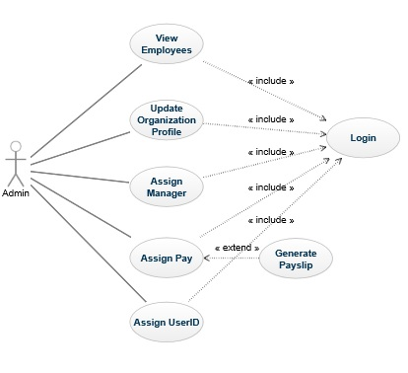

Use cases

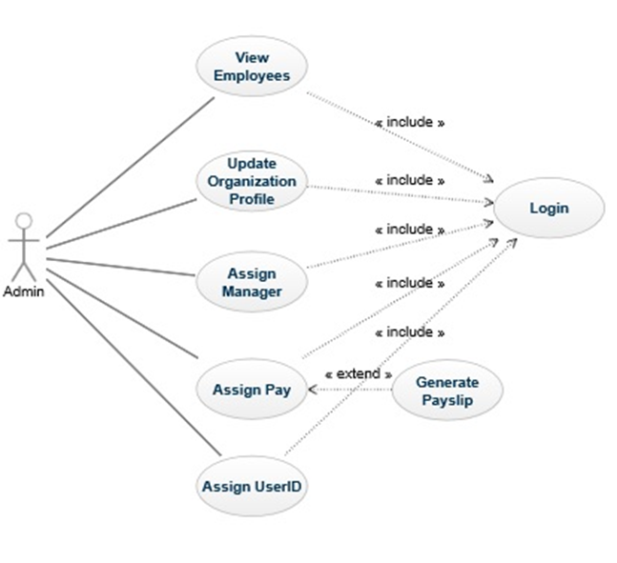

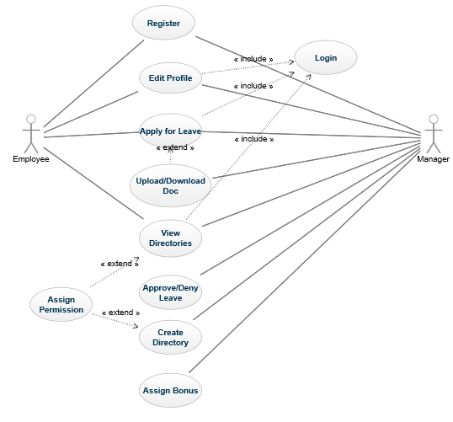

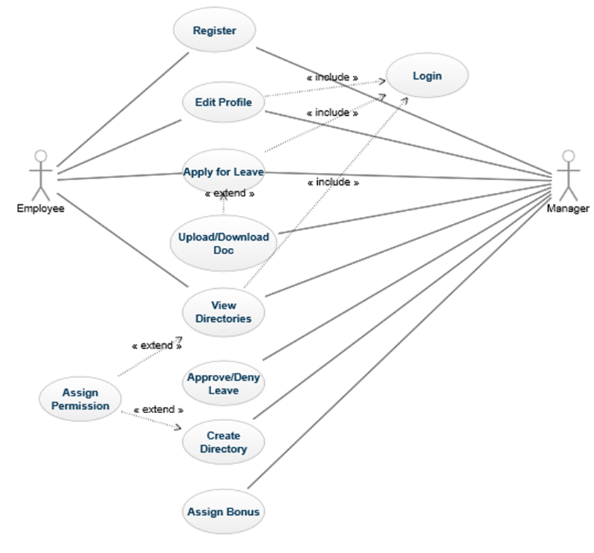

Class / Object
It should contain the class diagrams of every module in the system with different design patterns that you will use.
- This need to be updated for Next Lab

Non-Functional Requirements
The Non-Functional Requirements are the operations and activities that a system is supposed to do. It includes descriptions of the operation such as qualities, quality goals, quality of service and non-behavioral requirements.
- This need to be updated for Next Lab

Inverse Requirements
It should contain list of all inverse requirements that the project is restricted to.
- This need to be updated for Next Lab

Design Constraints
It should contain list of all the design constraints that are limiting the project.
- This need to be updated for Next Lab

Logical Database Requirements
It should contain list of all the logical database requirements that are needed for the project.
- This need to be updated for Next Lab

Other Requirements
It should contain list of any other requirements not covered elsewhere in the SRS. This might include internationalization requirements, legal requirements, reuse objectives for the project, and so on.
- This need to be updated for Next Lab

Analysis Models

List all analysis models used in developing specific requirements previously given in the SRS. Each model should include an introduction and a narrative description. Furthermore, each model should be traceable the SRS’s requirements.

Sequence Diagrams
It should contain the Sequence Diagrams of every module that shows the flow of logic within your system in a visual manner, enabling you both to document and validate your logic, and are commonly used for both analysis and design purposes.
- This need to be updated for Next Lab

State-Transaction Diagrams
It should contain the State Transition Diagrams of each state (The flow of each user from the beginning of interaction with the system).
- This need to be updated for Next Lab

Data Flow Diagrams
It should contain all the Data Flow Diagrams of each flow of data in a graphical representation.
- This need to be updated for Next Lab

